**Assignment Cover Sheet**

|  |  |  |
| --- | --- | --- |
| **Qualification** | | **Module Number and Title** |
|  | |
| BSc (Hons) in Software Engineering (4 Years) | | SE 1301 - Programming 01 |
| **Student Name & No.** | | **Assessor** |
| B W G K M Senarathne  KD/ICBT/BSCSE/01/14 | |  |
| **Handover Date** | | **Submission Date** |
| 16/07/2025 | | 06/08/2025 |
| **Assessment type**    Software Project | **Duration/Length of**  **Assessment Type**  Software Submission and document | **Weighting of Assessment**      50% |

|  |
| --- |
| **Learner**    **Declaration** |
| I, B W G K M Senarathne, KD/ICBT/BSCSE/01/14, certify that the work submitted for this assignment is my own and research sources are fully acknowledged. |

|  |  |  |  |
| --- | --- | --- | --- |
| **Marks Awarded** | | | |
| First assessor | |  | |
| IV marks | |  | |
| Agreed grade | |  | |
| Signature of the assessor |  | Date |  |

**FEEDBACK FORM**

**INTERNATIONAL COLLEGE OF BUSINESS & TECHNOLOGY**

**Module :** SE 1301 - Programming 01

**Student :** B W G K M Senarathne, KD/ICBT/BSCSE/01/14

**Assessor :**

**Assignment :** Software Project (University Enrollment System)



**Marks Awarded:**



**Assessor Feedback:**

**Feedback:**

**Contents**

**1.** **Test Plan** 4

**2.** **Test Case** 6

**Test Case 01** 6

**Test Case 02** 7

**Test Case 03** 9

**Test Case 04** 10

**Test Case 05** 11

**Test Case 06** 12

**Test Case 07** 13

**Test Case 08** 14

**Test Case 09** 16

**Test Case 10** 17

**3.** **Test Conclusion** 18

**Test Results** 18

**Recommendations** 18

**User Feedback** 18

**References** 19

# **Test Plan**

* Project Name: Student Information System for Central University.
* Duration: July 20, 2025 – August 3, 2025
* Objective: To develop an automated University Enrollment System for Student registration, Course enrollments, and keeping student records.
* Scope:
* User Login
* User Logout
* User-friendly Menus
* Student Enrollments and Withdrawals
* Course Roster
* File Handling
* Tester: Developer
* When writing Test Cases:

After development (August 2, 2025 - August 3, 2025)

* Testing Environment:
* Device: Aspire E5-576G
* Operating System: Windows 11
* Platform: Dev-C++
* Others: student.txt file, course.txt file, enrolled.txt file, SE.txt file, Enroll.txt file
* Approach:

This software project is tested by using the Top-Down approach. The diagram below represents the module hierarchy to test the software. Therefore, the system is supported to test separate user scenarios.

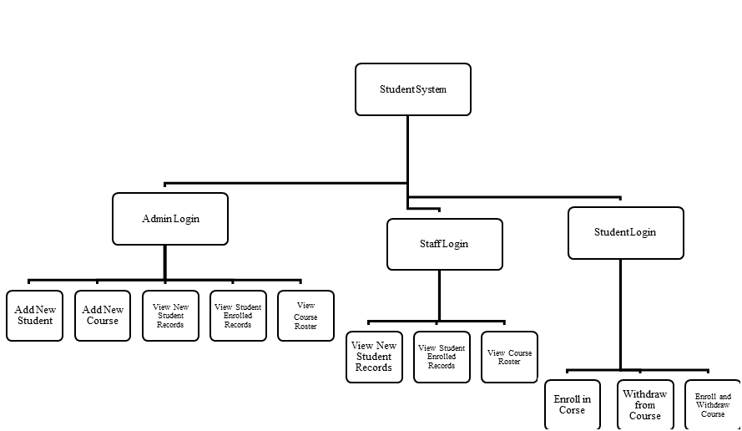

Figure 1: Top-Down Approach (Olha Holota from TestCaseLab, 2024)

* Methods:
* Unit Testing
* Grey Box Testing (geeksforgeeks, 2025)

Gray Box Testing is supported to test White Box Testing as internal C++ code testing and Black Box Testing as testing user inputs and outputs.

* Integration Testing
* Use scenario Testing

Test each scenario, such as User login, User logout, User-friendly menus, Student registration, Course enrollments, Course withdrawals, and maintaining student records, to ensure execution of the expected results.

# **Test Case**

The software project followed the test plan and executed with the following test results. (geeksforgeeks, 2025)

|  |  |  |  |
| --- | --- | --- | --- |
| **Test Case 01**: System login as Administrator | | | |
| Input | Expected Result | Actual Result | Status |
| User Name  Password | You have logged in Successfully. | You have logged in Successfully. | Pass |

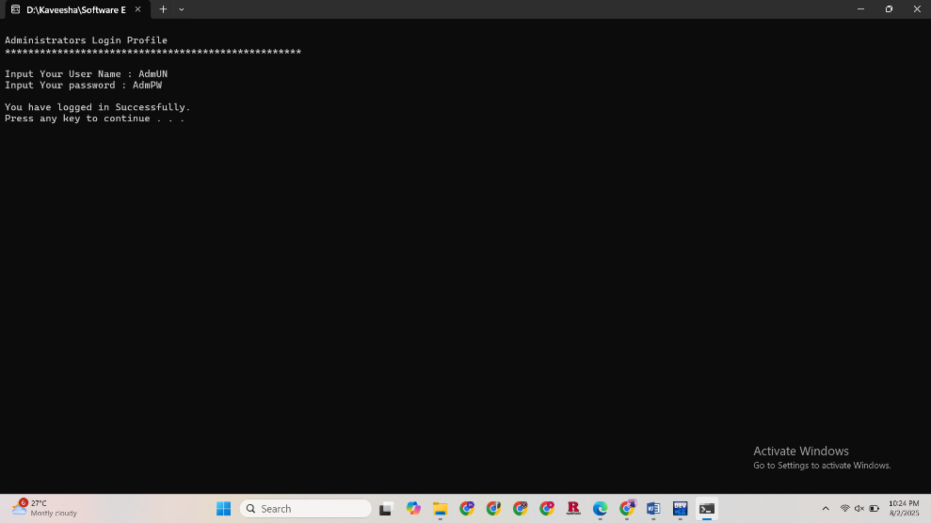

Figure 2: System login as Administrator

|  |  |  |  |
| --- | --- | --- | --- |
| **Test Case 02**: Add New Student Records by Administrator | | | |
| Input | Expected Result | Actual Result | Status |
| Add 5 student records (Only for testing) | Write 5 students' records in the student.txt file | Write 5 students' records in the student.txt file | Pass |

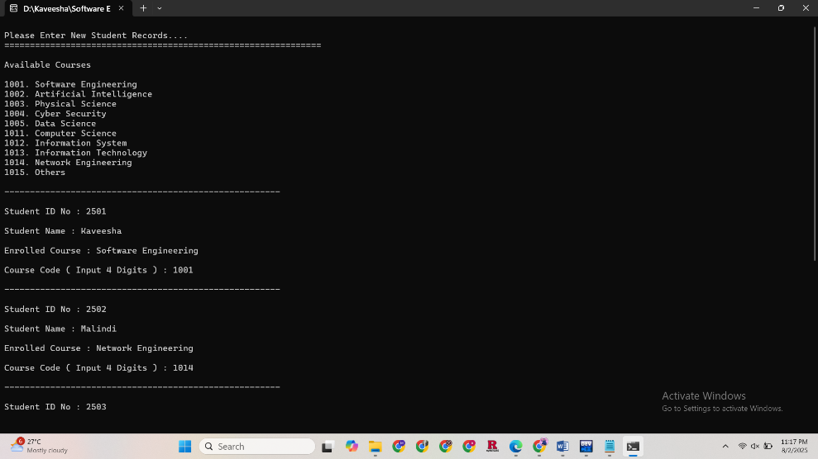

Figure 3: Input 5 student records

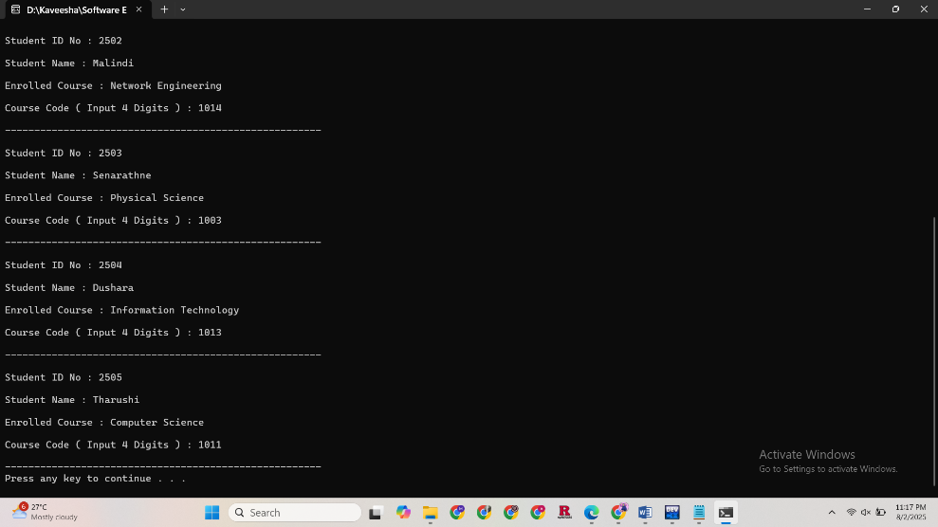

Figure 4: Input 5 student records

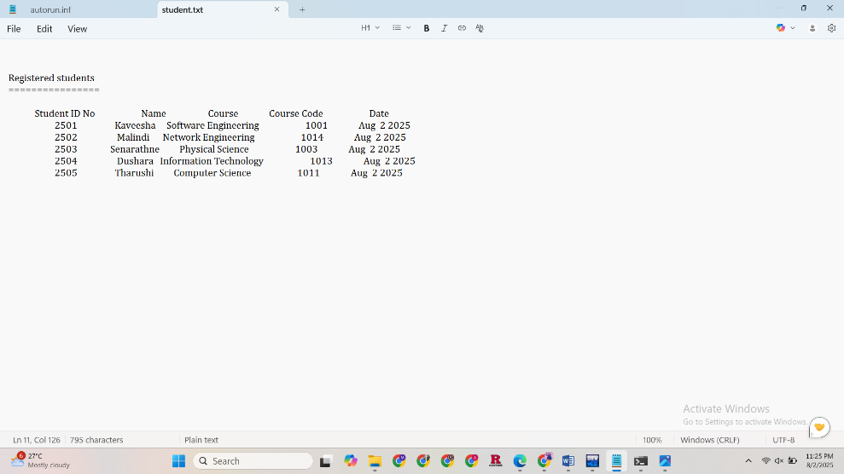

Figure 5: Output of student.txt file

|  |  |  |  |
| --- | --- | --- | --- |
| **Test Case 03**: Add New Course details by Administrator | | | |
| Input | Expected Result | Actual Result | Status |
| Add a course's details | Write the course details in the course.txt file | Write the course details in the course.txt file | Pass |

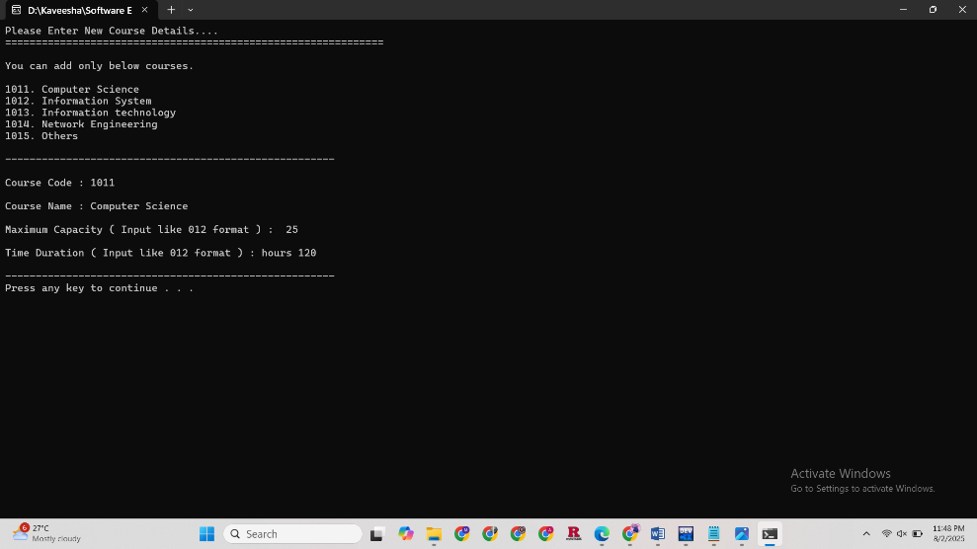

Figure 6: Input a course details

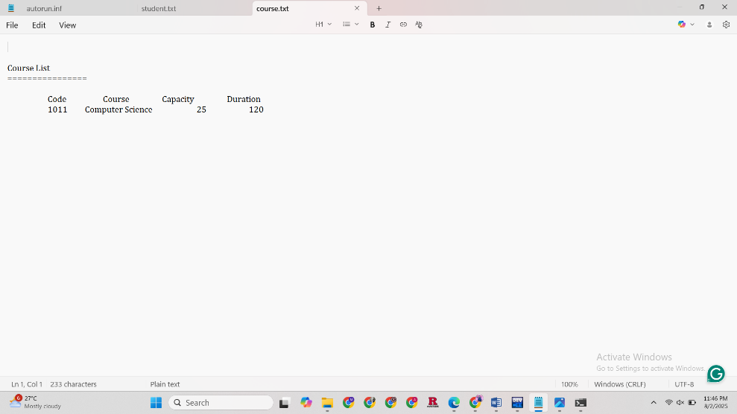

Figure 7: Output of student.txt file

|  |  |  |  |
| --- | --- | --- | --- |
| **Test Case 04**: System login as a Staff member using an invalid Password | | | |
| Input | Expected Result | Actual Result | Status |
| User Name  Password | Your Password is incorrect  You have 2 attempts remaining. | Your Password is incorrect  You have 2 attempts remaining. | Pass |

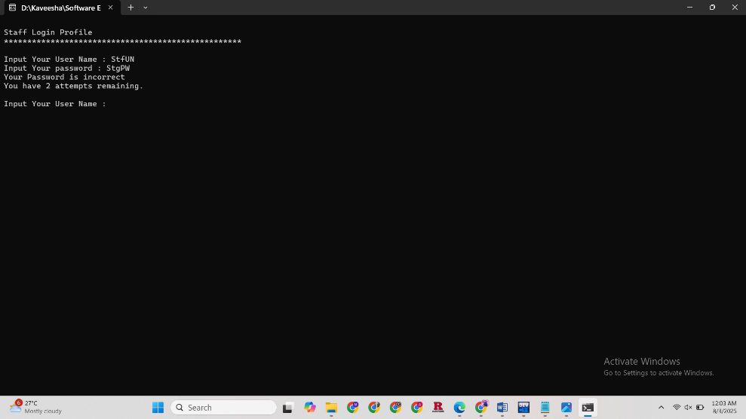

Figure 8: System login as a Staff member using an incorrect Password

|  |  |  |  |
| --- | --- | --- | --- |
| **Test Case 05**: View Student Enrolled Records by Staff Member | | | |
| Input | Expected Result | Actual Result | Status |
| In the staff menu, select choice 2 | Error: Could not open the enrolled.txt file. (Still empty file) | Error: Could not open enrolled.txt file. | Pass |

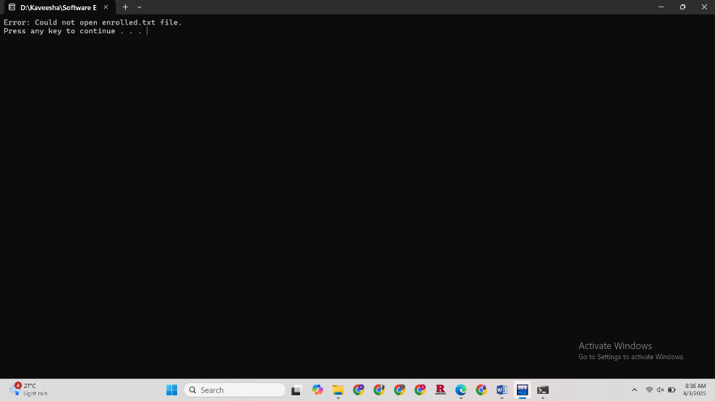

Figure 9: View Student Enrolled Records by Staff member

|  |  |  |  |
| --- | --- | --- | --- |
| **Test Case 06**: View a list of students enrolled in a Software Engineering Course | | | |
| Input | Expected Result | Actual Result | Status |
| In the Staff menu, select choice 3 | Read the SE.txt file | Read the SE.txt file | Pass |

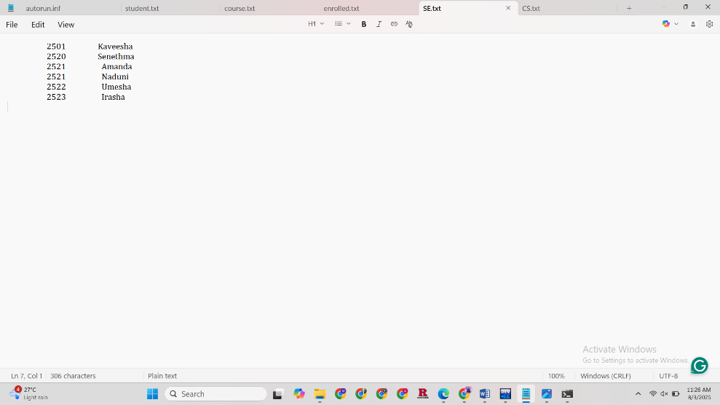

Figure 10: SE.txt file

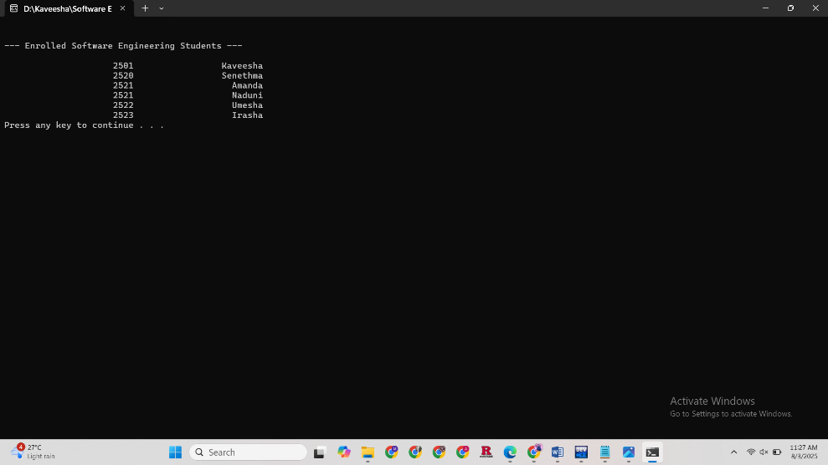

Figure 11: Read the SE.txt file

|  |  |  |  |
| --- | --- | --- | --- |
| **Test Case 07**: System login as a Student, and the System is locked | | | |
| Input | Expected Result | Actual Result | Status |
| Invalid Usernames and Passwords | SYSTEM IS LOCKED. | SYSTEM IS LOCKED. | Pass |

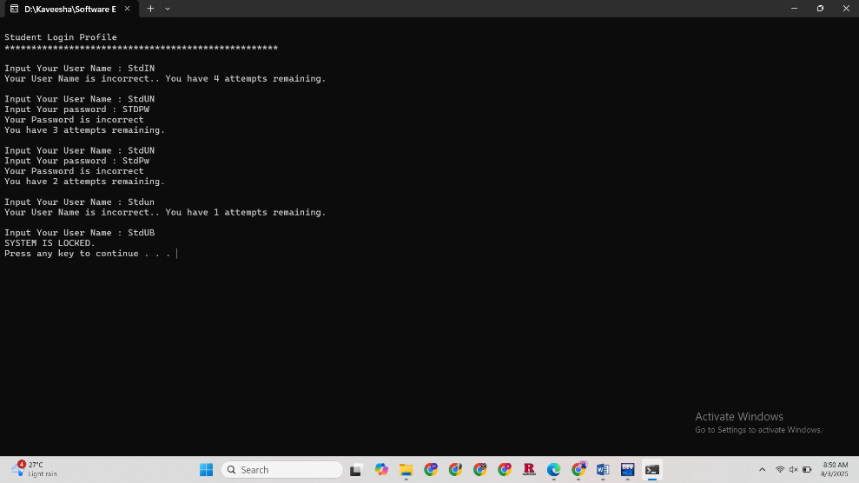

Figure12: System login as a Student, and the System is locked

|  |  |  |  |
| --- | --- | --- | --- |
| **Test Case 08**: Student follows the student menu step 3 and withdraws a Course | | | |
| Input | Expected Result | Actual Result | Status |
| Add 5 student records | Student ID marked as 0 in the enrolled.txt file | Student ID marked as 0 in the enrolled.txt file | Pass |

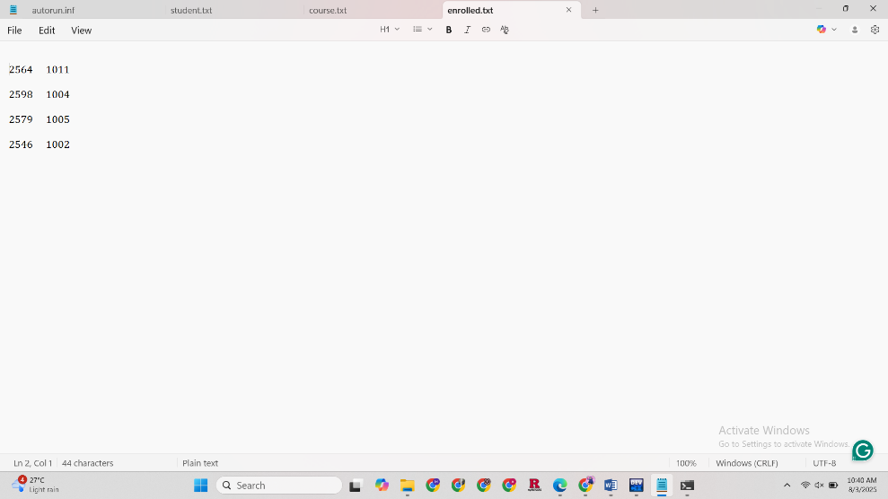

Figure 13: Before withdrawing the course

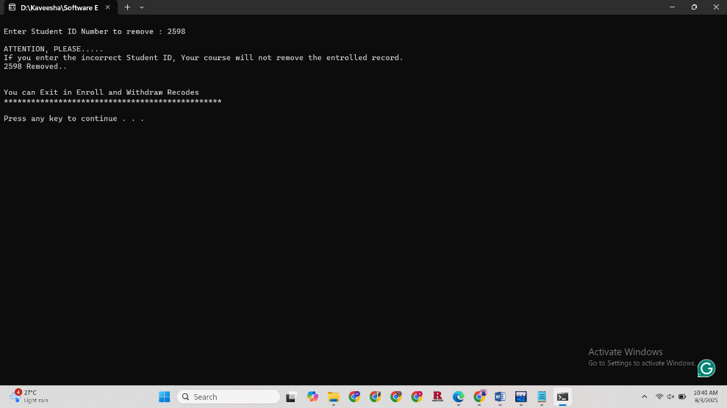

Figure 14: Withdraw the course using Student ID

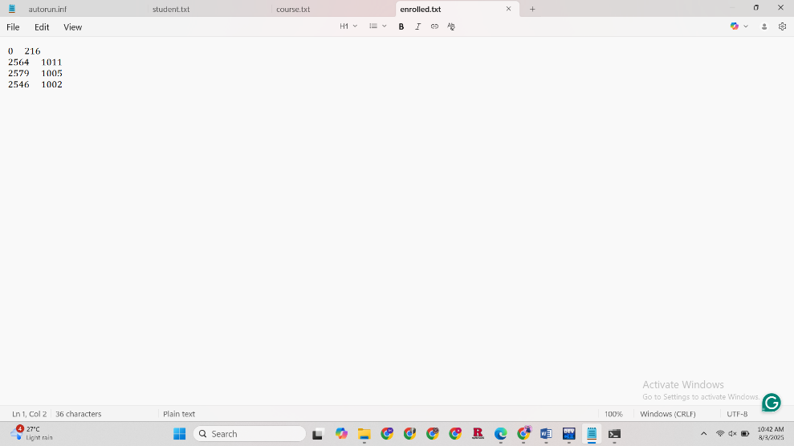

Figure 15: After withdrawing the course

|  |  |  |  |
| --- | --- | --- | --- |
| **Test Case 09**: Logout option in student menu | | | |
| Input | Expected Result | Actual Result | Status |
| In the student menu, select choice 4 | Return to the login interface | Return to the login interface | Pass |

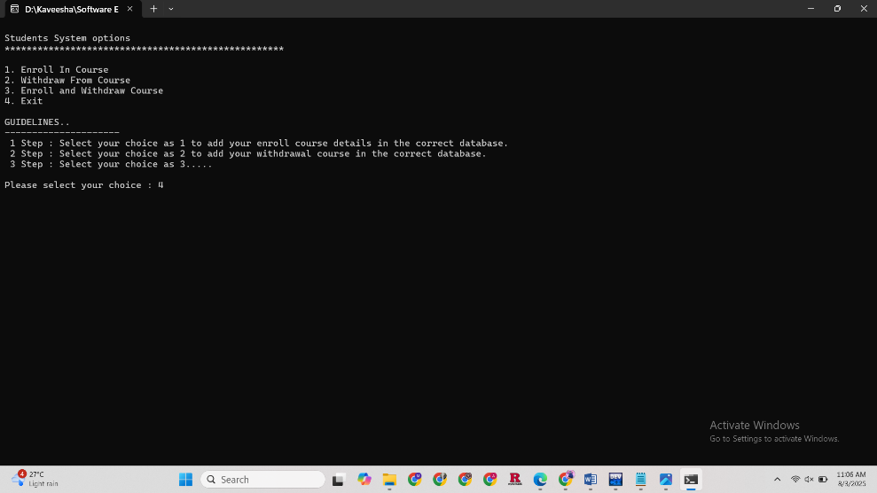

Figure 16: Logout option in student menu

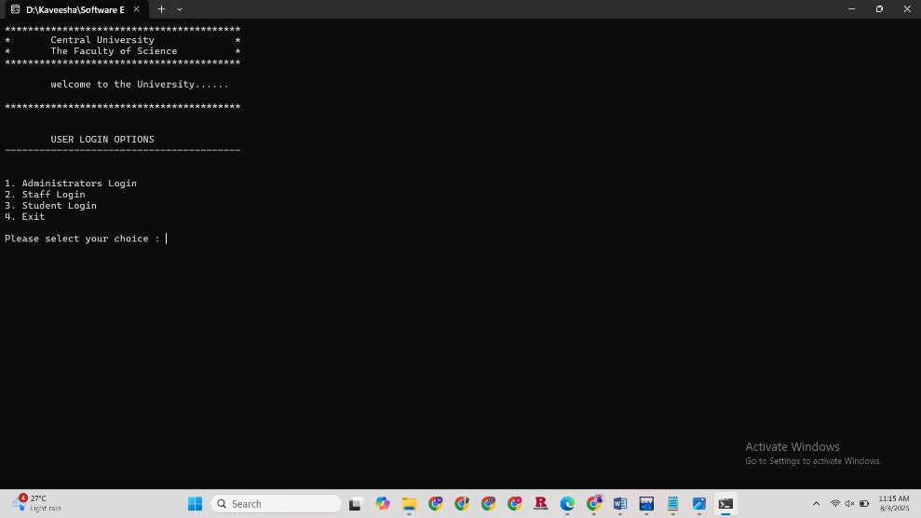

Figure 17: Return to the login interface

|  |  |  |  |
| --- | --- | --- | --- |
| **Test Case 10**: Add enrolled course details in the correct database | | | |
| Input | Expected Result | Actual Result | Status |
| In the student menu, select choice 1 | Write the enrolled course details in the Enroll.txt file | Write the enrolled course details in the Enroll.txt file | Pass |

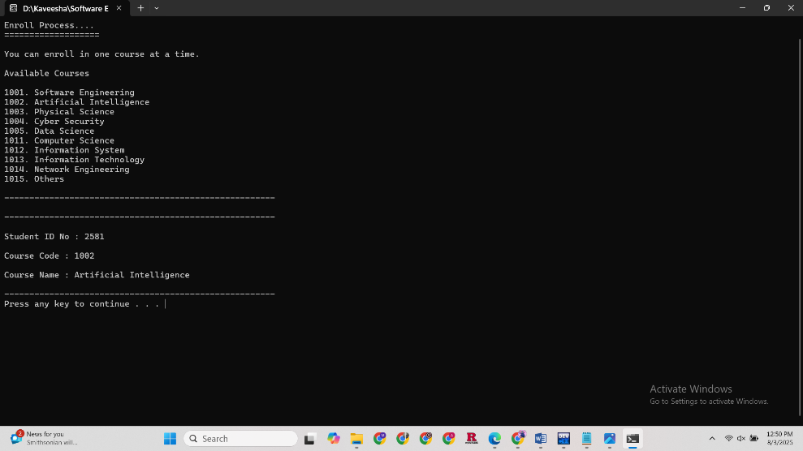

Figure 18: Input enrolled course details

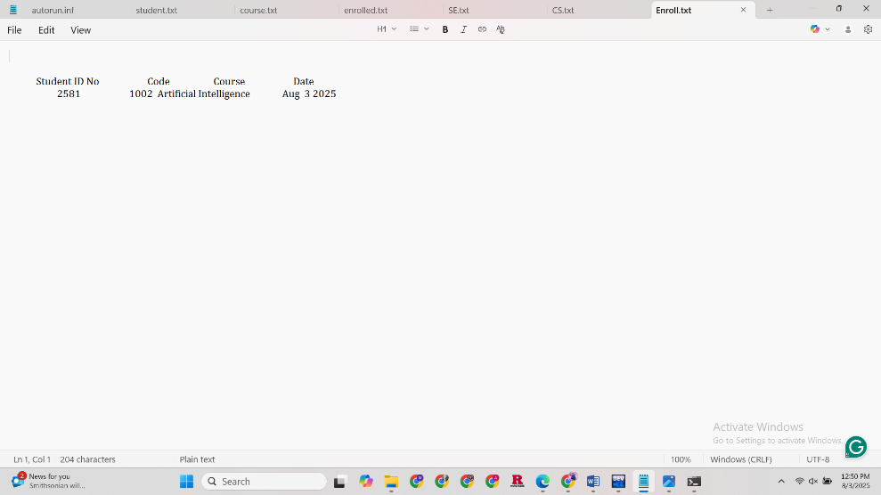

Figure 19: Enroll.txt file

# **Test Conclusion**

## **Test Results**

The software project utilized ten test cases in the testing process by the developer. The following table represents the progress of the test cases.

|  |  |  |
| --- | --- | --- |
| Total Test Cases | Passed | Failed |
| 10 | 10 | - |

As a result, the software system fulfils the expected requirements, such as User login, User logout, User-friendly menus, Student registration, Course enrollments, Course withdrawals, and keeping student records.

## **Recommendations**

* In Test Case 01 and Test Case 07, that observed the Password and Username should be hidden with asterisks. That will be more secure for unauthorized access. Therefore, the code could be implemented using <windows.h> header file. (geeksforgeeks, 2025)
* Moreover, when the system is locked, the user can unlock it by using the verification method.
* In Test Case 06, it was detected that the students' self-enrollment details were not written in the text file. Therefore, this option could be annexed to the system.

## **User Feedback**

* The system is used with proper guidelines to navigate the user. In contrast, Course enrollment and withdrawal options are a bit difficult to understand for users.
* Use an attractive interface for the software. For instance, the main menu is more creative.

# **References**

bloodshed, 2022. *Dev-C++ FAQs.* [Online]   
Available at: https://www.bloodshed.net/FAQ  
[Accessed 2 August 2025].

geeksforgeeks, 2025. *Software Testing Techniques.* [Online]   
Available at: https://www.geeksforgeeks.org/software-testing/software-testing-techniques/  
[Accessed 2 August 2025].

geeksforgeeks, 2025. *Taking password as input in C++.* [Online]   
Available at: https://www.geeksforgeeks.org/cpp/taking-password-as-input-in-cpp/  
[Accessed 3 August 2025].

geeksforgeeks, 2025. *Types of Software Testing.* [Online]   
Available at: https://www.geeksforgeeks.org/software-testing/types-software-testing/  
[Accessed 2 August 2025].

Malik, D., 2011. *C++ Programming,* Boston: Course Technology, Cengage Learning.

Olha Holota from TestCaseLab, 2024. *Introduction to Software Test Reporting.* [Online]   
Available at: https://medium.com/@case_lab/introduction-to-software-test-reporting-332e1b1a17ff  
[Accessed 2 August 2025].